DONATE

WHILE

**YOU DINE**

**Come to the Culver’s of Crystal Lake to help support COTA in honor of EMMA KOTECKI. Stop in on March 27th from 5pm to 8pm (Dine in, Drive-Thru and pick up all eligible).**

**THANK YOU FOR YOUR SUPPORT!**

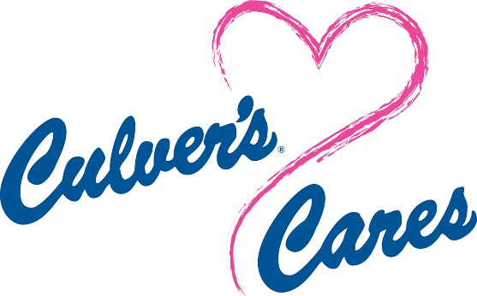

**CRYSTAL LAKE CULVER’S**

**400 PINGREE ROAD, CRYSTAL LAKE, IL, 60014**