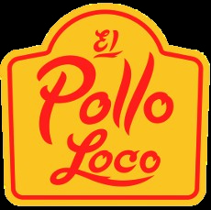

JOIN US FOR A

# Fire-grilled fundraiser

Come enjoy fire-grilled chicken while also supporting a great cause!

Children's Organ Transplant Association

Visit the El Pollo Loco location listed below on the designated date.

Bring this flyer. El Pollo Loco will donate **30%** of the proceeds to us!

Participants must present this flyer to the cashier at the time of purchase.

Flyers cannot be distributed in or around the restaurant.

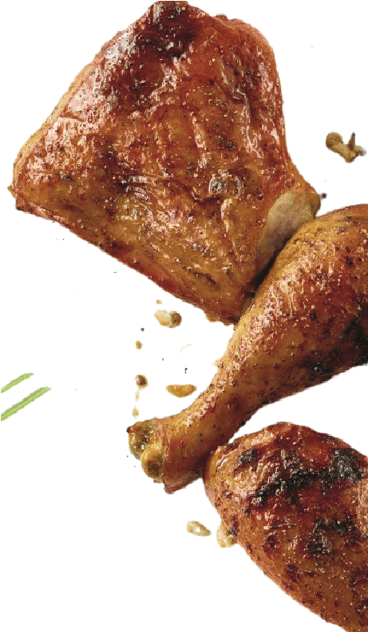SEP 7, 2024

**44402 Valley Central Way, Lancaster**

**10 am - 10 pm**

**Thank you in advance for your support! Interested in fundraising?**

**Contact Karla Ortiz at** [**karla.ortiz@wksusa.com**](mailto:karla.ortiz@wksusa.com)

