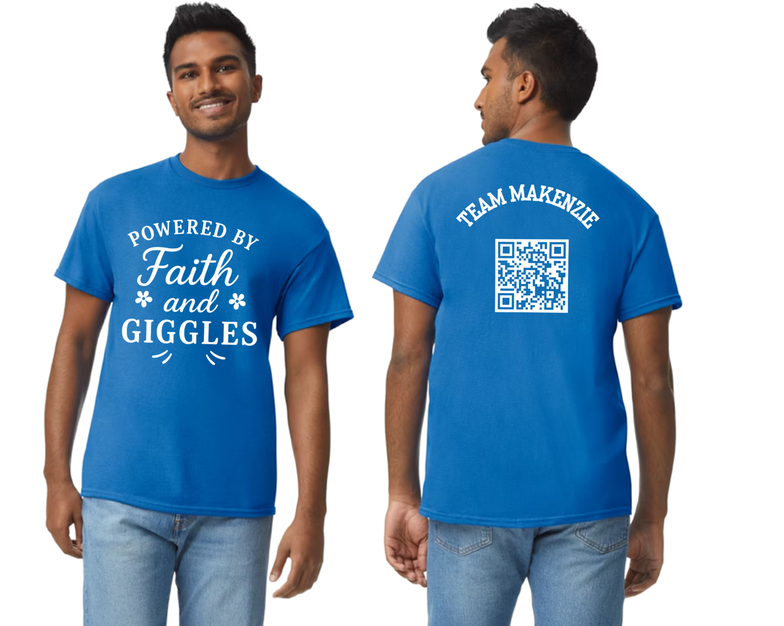
T-Shirt Order Form
COTA in honor of Team Makenzie

Team Member taking Orders:

Name: ___________________________________________
Phone: __________________________________________
Email: ___________________________________________
Person Ordering:  Name and Phone | Size | Pink ~or~ Blue | $20 Each | Total
 |  |  |  | $
 |  |  |  | $
 |  |  |  | $
 |  |  |  | $
 |  |  |  | $
 |  |  |  | $
 |  |  |  | $
 |  |  |  | $
 |  |  |  | $
 |  |  |  | $
Cash Only
SIZES:
Youth: YS, YS, YM, YL
Adult: S, M, L, XL, 2XL, 3XL
Total Due: $
Signature:
Date Submitted:
ALL MONEY FOR T-SHIRTS MUST BE TURNED INTO
JUDITH FORD BEFORE ORDER CAN BE PLACED!

